**WEEK-2**

**Exercise 2: E-commerce Platform Search Function**

**CODE:**

import java.util.*;

public class Main {

public static List<String> productList = Arrays.asList(

"Apple iPhone 15",

"Samsung Galaxy S23",

"Sony Wireless Headphones",

"Apple Watch",

"Dell Laptop",

"Samsung Smart TV",

"Canon DSLR Camera",

"Apple AirPods"

);

public static List<String> searchProducts(String keyword) {

List<String> results = new ArrayList<>();

String lowerKeyword = keyword.toLowerCase();

for (String product : productList) {

if (product.toLowerCase().contains(lowerKeyword)) {

results.add(product);

}

}

return results;

}

public static void main(String[] args) {

Scanner scanner = new Scanner(System.in);

System.out.print("Enter search keyword: ");

String keyword = scanner.nextLine();

List<String> matches = searchProducts(keyword);

if (matches.isEmpty()) {

System.out.println("No products found for: " + keyword);

} else {

System.out.println("Matching products:");

for (String product : matches) {

System.out.println("- " + product);

}

}

}

}

**OUTPUT:**

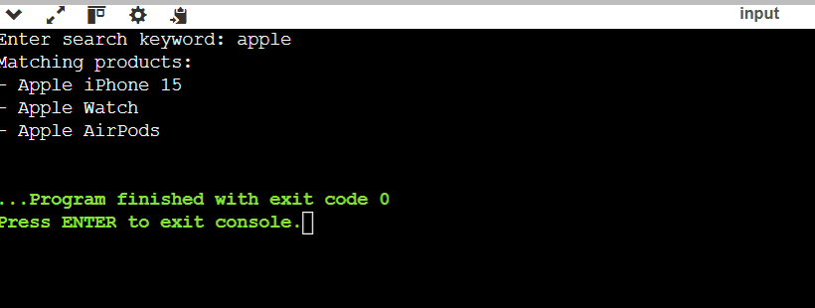

**Exercise 3: Financial Forecasting**

**CODE:**

import java.util.*;

public class Main {

public static List<Double> forecastRevenue(List<Double> pastRevenue, int monthsToForecast) {

List<Double> forecast = new ArrayList<>();

int n = pastRevenue.size();

double growthRate = (pastRevenue.get(n - 1) - pastRevenue.get(0)) / pastRevenue.get(0);

double avgMonthlyGrowth = growthRate / (n - 1);

double lastRevenue = pastRevenue.get(n - 1);

for (int i = 1; i <= monthsToForecast; i++) {

lastRevenue = lastRevenue + (lastRevenue * avgMonthlyGrowth);

forecast.add(lastRevenue);

}

return forecast;

}

public static void main(String[] args) {

Scanner scanner = new Scanner(System.in);

System.out.print("Enter number of past months: ");

int pastMonths = scanner.nextInt();

List<Double> revenueList = new ArrayList<>();

System.out.println("Enter revenue for each month:");

for (int i = 0; i < pastMonths; i++) {

revenueList.add(scanner.nextDouble());

}

System.out.print("Enter number of future months to forecast: ");

int forecastMonths = scanner.nextInt();

List<Double> forecast = forecastRevenue(revenueList, forecastMonths);

System.out.println("Forecasted revenue:");

for (int i = 0; i < forecast.size(); i++) {

System.out.printf("Month %d: %.2f\n", i + 1, forecast.get(i));

}

}

}

**OUTPUT:**

